
Hoo Progression Steps
Year 1

Cooking and Nutrition
- Talk about what I eat at home and discuss what healthy foods are
- Say where some foods come from and give examples of food which is grow
- Use simple tools, under supervision, to prepare food in a safe way
Processes
- Create simple designs for a product and its packaging
- Use pictures and words to tell others what I need to do
- Select from and use a range of tools to carry out simple practical tasks:
- cutting, shaping, joining and finishing
- Use a range of simple tools to cut, combine and join materials safely
- Ask simple questions about existing products and those I have made
- Build structures, exploring how they can be made stronger, stiffer and more stable Use wheels and axles in product

Learning
- Use artwork to record ideas, observations and experiences
- Experiment with different materials to design and make products
- Explain what I like about the work of others
- Know the names of tools, techniques and elements I use in my
- artwork
Techniques
    - Use a variety of tools including pencils, rubbers, crayons, pastels, felt tips, charcoal, ballpoints, chalk and other dry media to represent objects in lines.
    - Explore mark-making using a variety of tools
    - Make structures by joining simple objects together
    - Cut, glue and trim materials to create images from a variety of media e.g
    - photocopies, fabric, crepe paper, magazines
    - Make marks in print using found objects and basic tools and use these to create repeating patterns
    - Sort, cut and shape fabrics and experiment with ways of joining them


Geography

Geographical Skills & Fieldwork
- Ask simple geographical questions
- Use simple observation skills to study the geography of the school and its grounds
- Use simple maps of the local area
- Use simple locational and directional language – near/far left/right
- Make simple maps and plans
Locational Knowledge
- Understand how places are linked to each other – roads, trains, plans
Human and physical geography
- Describe seasonal weather changes
Place Knowledge
- Name, describe and compare familiar places
- Link their home with other places in the local community
- Know about present changes that are happening in the local environment i.e. school/in town
- Suggest ideas for improving the school environment

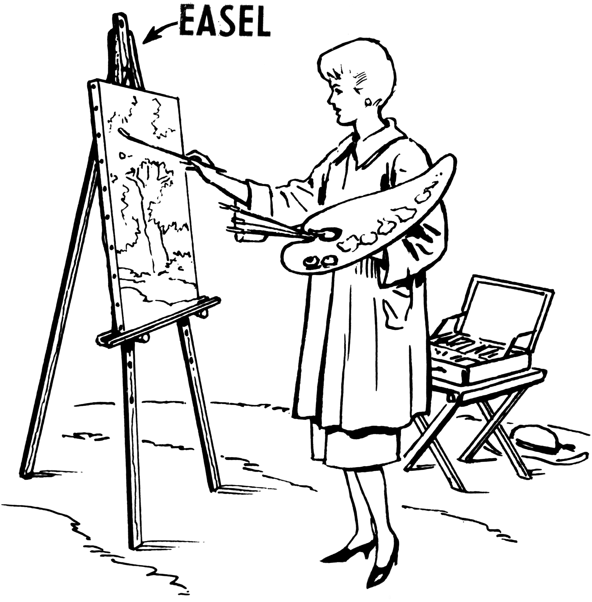
DT
ART DESIGN



- Computers
- Recognise common uses of information technology in the home and
- school environment
- Recognise some ways in which the internet can be used to communicate
Using a Computer
- Use technology purposefully to create digital content
- Use the internet with adult support to communicate with people I know
- Give examples on how to communicate with people I know
- I can talk about how I can use the internet to find things out
E Safety
- Describe ways in which people can be unkind online
- Offer examples of how this can make others feel
- I can identify some simple examples of my personal information (e.g. name, address, birthday, age, location)
- I can describe the people I trust and can share my personal information with them and I can explain why I can trust them.
- Understand where to go for help and support when I have concerns about content of contact on the internet or other online technologies
Coding
- Predict the behaviour of simple programs
- Understand what algorithms are and how they are implemented on digital devices
Self-Image & Identity/Copyright and Ownership
- I can recognise that I can say no, Ill tell, please stop to somebody who asks me to do something that makes me feel sad, embarrassed or upset
- I can recognise that there may be people online who could make me feel sad, embarrassed or upset
- I know that work I create belongs to me
- I can name my work so that others know it belongs to me

Computing
RE

Beliefs and Teachings
- Talk about some stories from the bible
Religious Practices and Lifestyles
- Recognise some religious objects, places, people and practices
Ways of Expressing Meaning
- Recognise basic religious symbols and use some basic religious vocabulary correctly
Human Identity, Personality and Experience
- Express my own opinions about what is important in my life
Questions of Meaning and Purpose
- Discuss questions which might not have an answer
Values and Commitments
Talk about things being fair and unfair

- Listen to music with sustained concentration
- Find the pulse whilst listening to music and using movement
- Use the correct musical language to describe a piece of music
- Recognise different instruments
- Discuss feelings and emotions linked to a different piece of music
- Begin to understand that rhythm is a mixture of long and short sounds that happen over the pulse
- Listen to, copy and repeat simple rhythm or melody
- Understand that pitch describes how high or low sounds are
- Understand that tempo describes how fast or slow the music is
- Understand that dynamics describes how loud or quiet the music is
- Learn and perform chants, rhythm, raps and songs
- Learn to follow the conductor or band leader
- Sing songs musically and understand how to warm up and project the voice whilst holding a good posture
- Play instruments using the correct techniques with respect
- Start to choose, organise and combine musical patters
- Start to understand basic musical notation
- Practice, rehearse and present performances to audiences with a growing awareness of the people watching
- Experiment with, crate, select and combine sounds
Music



History
Chronological Understanding
- Sequence some events or 2 related objects in chronological order
- Uses words and phrases: old, new, young, days, months
- Sequence events and recount changes within living memory
- Remembers parts of stories and memories about the past
Knowledge and understanding of past events, people and changes in the past
- Tell the difference between past and present in own and other people’s lives
- Identify some similarities and differences between ways of life in different periods
Historical Interpretation
- Begins to identify and recount some details from the past from sources (e.g. pictures, stories)
- Relate my account of an event and understand that others may give a different version
Historical Enquiry
- Find answers to simple questions about the past from sources of information (e.g. pictures, stories, artefacts)
- Describe simple similarities and differences between artefacts
- Sort artefacts from “then” and “now”
- Ask and answer basic questions about the past
Organisation and Communication
- Shows knowledge and understanding about the past in different ways (e.g. role play, drawing, writing and talking)

Working Scientifically
- Ask simple questions about the topic and know that they can be answered in different ways
- Use simple equipment to make simple observations
- Perform simple tests
- Identify and classify groups
- Use observations made to suggest answers to questions
- Collect and record simple data to help in answering questions
Animals Including Humans
- Identify and name a variety of common animals including fish, amphibians, reptiles, birds and mammals
- Identify and name a variety of common animals that are carnivorous, herbivories and omnivores
- Describe and compare the structure of a variety of common animals
- Identify, name, draw and label the basic parts of the human body
- Say which part of the body is associated with each sense
Materials
- Tell the difference between an object and the material from which it is made
- Identify and name a variety of every day materials, including wood, plastic, glass, metal, water and rook
- Describe the physical properties of some everyday materials
- Compare and group together a variety of everyday materials on the basis of their simple physical properties
Plants
- Identify and name a variety of common wild and garden plants including deciduous and evergreen trees
- Identify and describe the basic structure of a variety of common flowering plants, including trees
Seasonal Changes
- Observe changes across the four seasons
- Observe and describe the weather associated with the seasons and how day length varies
Science

