DT
Cooking & Nutrition
- Understand the need for a variety of food in a diet
- Understand that all food needs to be farmed, grown or caught
- Use a wider range of cookery skills to prepare food safely
Processes
- Design useful, functional and appealing products based on a design criteria
- Generate, develop and model my ideas through talking, drawing, templates, mock-ups and where appropriate using ICT
- Choose suitable tools and materials based on my knowledge of their properties
- Safely measure, mark out, cut out and shape materials and components using a range of tools
- Evaluate and assess existing products and those that I have made using a design criteria
- Investigate different techniques for stiffening a variety of materials and investigate how to make structures stable
- Explore and use mechanisms e.g levers, sliders, wheels and axles in my products

Hoo Progression Steps
Year 2

Beliefs and Teachings
- Describe some religious ideas from stories and some basic religious beliefs about teachings
Religious Practices and Lifestyles
- Describe some religious objects and start to identify similarities between different religions
Ways of Expressing Meaning
- Begin to suggest meanings for some religious actions and symbols and describe how religious belief is expressed in different ways
Human Identity, Personality & Experience
- Respond sensitively to own and other’s experiences and feelings
Questions of Meaning and Purpose
- Ask questions about puzzling aspects of life and experiences and suggest answers
Values And Commitments
- Describe some religious values in relation to matters of right and wrong and make links between these and my own values.

Learning
- Try out different activities and make sensible choices about what to do next
- Select particular techniques to create a chose product and develop some care and control over materials in my use
- Give reasons for my preferences when looking at art/craft or design work
- Know that different artistic works are made by craftspeople from different cultures and times
Techniques
- Experiment with tones using pencils, chalks or charcoal
- Represent things observed, remembered or imagined using colour or tools
- Experiment with basic tools on rigid and flexible materials
- I am able to make textured collages from a variety of media and by folding, crumpling and tearing materials
- Use a variety of techniques including carbon printing, relief, press and fabric printing and rubbings
- Develop techniques to join fabrics and apply decorations such as a running or over stich


RE

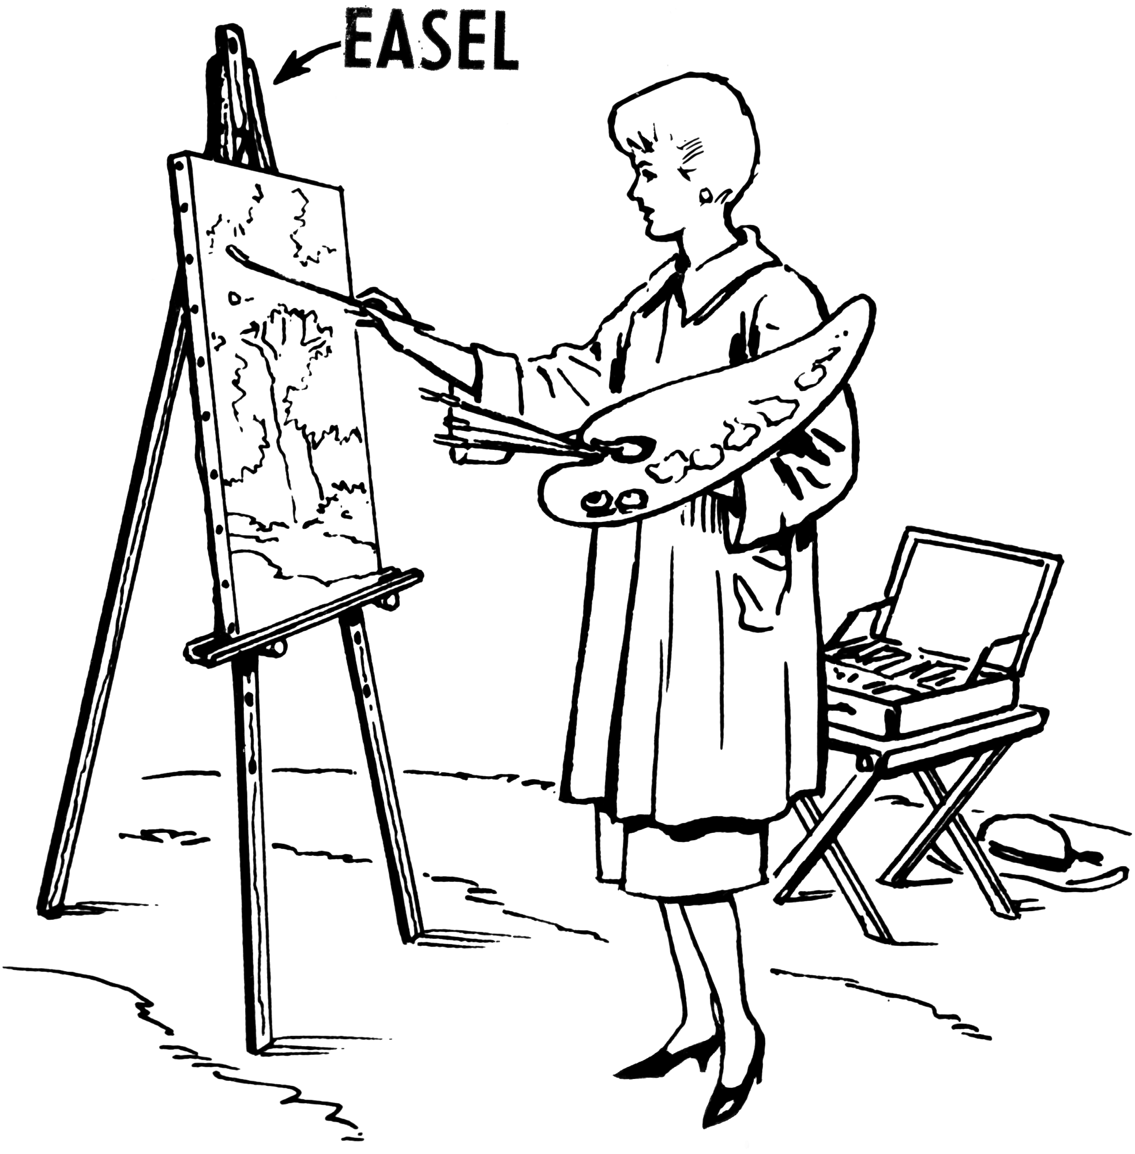
ART DESIGN

Geography
History

Chronological Understanding
- Recount changes in own life over time
- Puts 3 people, events or objects in order using a given scale
- Uses works and phrases such as recently, before, after, now, later
- Uses past and present when telling others about an event.
Knowledge and Understanding of Past Events, People and Changes in the Past
- Uses information to describe the past
- Uses information to describe differences between then and now
- Recounts main events from a significant period in history
- Uses evidence to explain reasons why people in past acted as they did
Historical Interpretation
- Describes significant historical events, people and places on the locality
- Looks at books and pictures (and eye-witness accounts, photos, artefacts, buildings and visits, internet).
- Understands why some people in the past did things
- Describes events beyond living memory that are significant nationally or globally
- Describes changes within living memory and aspects of change in national life
Historical Enquiry
- Looks carefully at pictures or objects to find information about the past
- Asks and answers questions such as: ‘what was it like for a ….?’, ‘what happened in the past?’, ‘how long ago did…. Happen?’.
- Estimates the ages of people by studying and describing their features
Organisation and Communication
- Describes objects, people and events
- Writes own date of birth
- Writes simple stories and recounts about the past
- Draws labelled diagrams and writes about them to tell others about people, events and objects from the past.

- Geographical Skills & Fieldwork
- Use world maps, atlases and globes to identify the UK and its countries
- Be able to locate, using maps, atlases and globes, any countries / continents and oceans studied
- Use the four compass points (N, S, E, W) and locational directions (near, far, left and right) to describe the features and routes on a map.
- Use aerial photographs of the local area to recognise landmarks and basic human and physical features.
- Draw simple maps of the local area (not to scale) and be able to devise a simple key for their maps.
- Use simple fieldwork and observational skills to study the geography of the school and its grounds.
- Use simple fieldwork and observational skills to study the geography of Hoo Village.
Locational Knowledge
- Name and locate on a world map the seven continents and five oceans
- Name, locate and identify characteristics of the four countries and capital cities of the UK
- Name and locate the seas surrounding the UK
Human and Physical Geography
- Identify seasonal and daily weather patterns in the UK
- Identify hot and cold areas of the world in relation to the Equator and the North & South Poles
- Use basic geographical vocabulary to refer to key physical features including: river, beach, cost, forest, mountain, sea, ocean, soil, valley, season and weather
- Use basic geographic vocabulary to refer to key human features including: village, town, city, factory, castle, house, port, harbour, shop
Place Knowledge
- Understand geographic similarities and differences through studying the human and physical geography of a small area of the UK and of a small area in a contrasting non-European country

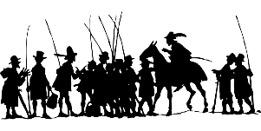


Computing Continued

- Explain how information online about me can last for a long time
- Know who to talk to if someone has made a mistake about putting something online
- I can recognise more detailed examples of information that is personal to me – names of people in my family, where I go school etc.
Coding
- Use logical reasoning to predict the behaviour of simple programs
- Create simple programs
- Create and debug simple programs
- Debug simple programmes by using logical reasoning to predict the actions instructed by the code
- Understand that programs execute by following precise and unambiguous instructions
- I can explain how other people’s identity online can be different to their identity in real life
- I can describe ways in which people might make themselves look different online
- I can give examples of issues online that might make me feel sad, worried, uncomfortable or frightened. I can give examples of how I might get help.
- I can explain why work I create using technology belongs to me – it is my idea / I designed it
- I can save my work so that others know it belongs to me (filename, name of content)
Online Relationships
- Explain why it is important to be considerate and kind to people online

Computers
- Recognise common uses of information technology beyond school
Using a Computer
- Use technology purposefully to create, organise, store, manipulate and retrieve digital content
- Identify ways that information can be put onto the internet
- Use technology purposefully to create digital content comparing the benefits of different programs
- Use the internet to communicate with people I do not know well
- Identify devices to access information on the internet
- Talk about how I can use the internet to find things out
- I can identity devices I could use to access information on the internet
- I can use simple keywords in search engines
- Give simple examples of how to find information on the internet
- I can demonstrate how to navigate a simple back page to get information I need (home/back/forward/tabs) etc
E-Safety
- I can explain how passwords can be used to protection information and devices
- Describe how to behave online in ways that do not upset others
- Give examples of bullying behaviour and how it could look online
- Understand how bullying can make someone feel
- Explain how someone would get help about being bullied online or offline
- Use technology safely and keep personal information private
- Recognise that information can stay online and could be copied
- I can explain why I should always ask a trusted adult before I share any information about myself online
- Describe what information should not go online without asking a trusted adult first

Computing

Music

- Listen with concentration and understanding to a range of recorded and live music
- Build an understanding of the pulse and internalise it when listening to a piece of music.
- Begin to recognise and example different musical styles.
- Begin to develop an understanding of the history of music.
- Improvise a simple rhythm using different instruments including the voice
- Understand that the timbre describes the character or quality of the sound
- Understand that texture describes the layers within the music
- Understand that structure describes how different sections of the music are ordered for effect and pattern
- Begin to be able to describe a piece of music using timbre, texture and structure
- Use voice expressively and creatively by singing songs and speaking chants and rhymes with growing confidence
- Develop an understanding of melody, the words and their importance in the music being listened to
- Sing a song in two parts
- Use tuned and untuned
- classroom percussion to play accompaniments and tunes
- Perform an ensemble using a variety of instruments and play different parts where appropriate

Science

Working Scientifically
- Ask simple questions and recognise that they can be answered in different ways including use of scientific language from the topics studied.
- Use simple equipment to observe changes over time
- Perform simple comparative tests
- Identify groups and classify
- Use observations to suggest answers to questions noticing similarities,
differences and patterns
Animals including Humans
- Understand that animals, including humans, have babies which grow into adults
- Describe the basic needs of animals, including humans, for survival
- Describe the importance for humans of exercise, a balanced diet, and hygiene
Materials
- Compare the suitability of a variety of everyday materials for particular uses
- Describe how the shape of solid objects made from some materials can be changed by squashing, bending, twisting and stretching
Plants
- Explain how seeds and bulbs grow into plants
- Describe how plants need water, light and a suitable temperature to grow and stay healthy
Living Things and Their Habitats
- Explain the difference between things that are living, dead and things that have never been alive
- Identify that most living things live in habits in which they are suited
- Describe how different habitats provide for the basic needs of different kinds of animals and plants
- Describe how animals and plants depend on each other for survival
- Identify and name a variety of plants and animals in their habitat including micro-habitats
- Describe how animals obtain their food from plants and other animals using the idea of a simple food chain.

