Cooking & Nutrition
- Talk about the different food groups and name foods from each group.
- Understand that all food needs to be farmed, grown or caught in Europe and the wider world
- User a wider variety of ingredients and techniques to prepare and combine ingredients safely
Processes
- Use knowledge of exiting product to design my own functional product
- Create designs using annotated sketches, cross-sectional diagrams and simple computer programmes
- Safely measure, mark-out, cut, assemble, join with some accuracy
- Make suitable choices from a wider range of tools and unfamiliar materials and plan out the main stages of using them
- Investigate and analyse existing products that I have made
- Strengthen frames using diagonal struts
- Understand how mechanical systems such as levers and linkages or pneumatic systems create movement

RE



Beliefs and Teachings
- Develop some religious vocabulary to describe key features and know beliefs, ideas and teachings for some religions
- Religious Practices and Lifestyles
- Have some awareness of key similarities and differences of objects, places and people with Religious practices and lifestyles
- Ways of Expressing Meaning
- Begin to identify the impact of religious teachings, including the effect sacred texts have on believers’ lives
- Begin to identify religious symbols and symbolic actions
- Human Identity, Personality and Experience
- Recognise what influences me in my life and how religion may influence me and my family
- Questions of Meaning and Purpose
- Identify ultimate questions and understand that there are no universally agreed answers to such questions.
- Values and Commitments
- Recognise that religious may ask believers to do certain things, follow certain actions and show their faith in particular ways

DT
Hoo Progression Steps
Year 3

- Listen with direction to a range of high-quality music
- Confidently recognise a range of musical instruments
- Find the pulse within eh context of different songs/music with ease
- Understand the improvisation is when a composer makes up a tune within boundaries
- Understand that composition is when a composer writes down and records a musical idea
- Sing songs with multiple parts with increasing confidence
- Play and perform in solo or ensemble contexts with confidence
- Develop an understanding of formal, written notation which includes crotchets and rests
- Begin to listen to and recall sounds with increasing aural memory

Learning
- Use a sketchbook for recording observations, for experimenting with techniques or planning out ideas.
- Experiment with different materials to create a range of effects and use these techniques in the completed piece of work.
- Explain what I like or dislike about my work.
- Know about some of the great artists, architects and designers in history and describe their work.
Techniques
- Explore shading, using different media
- Understand and identify key aspects such as complementary colours, colours as a tone, warm and cold colours
- Compare and recreate form of natural and manmade objects
- I am able to create a collage using overlapping and layering
- Create printing blocks using relief or impressed techniques
- Add details to work using different types of stitch, including cross-stich

Music
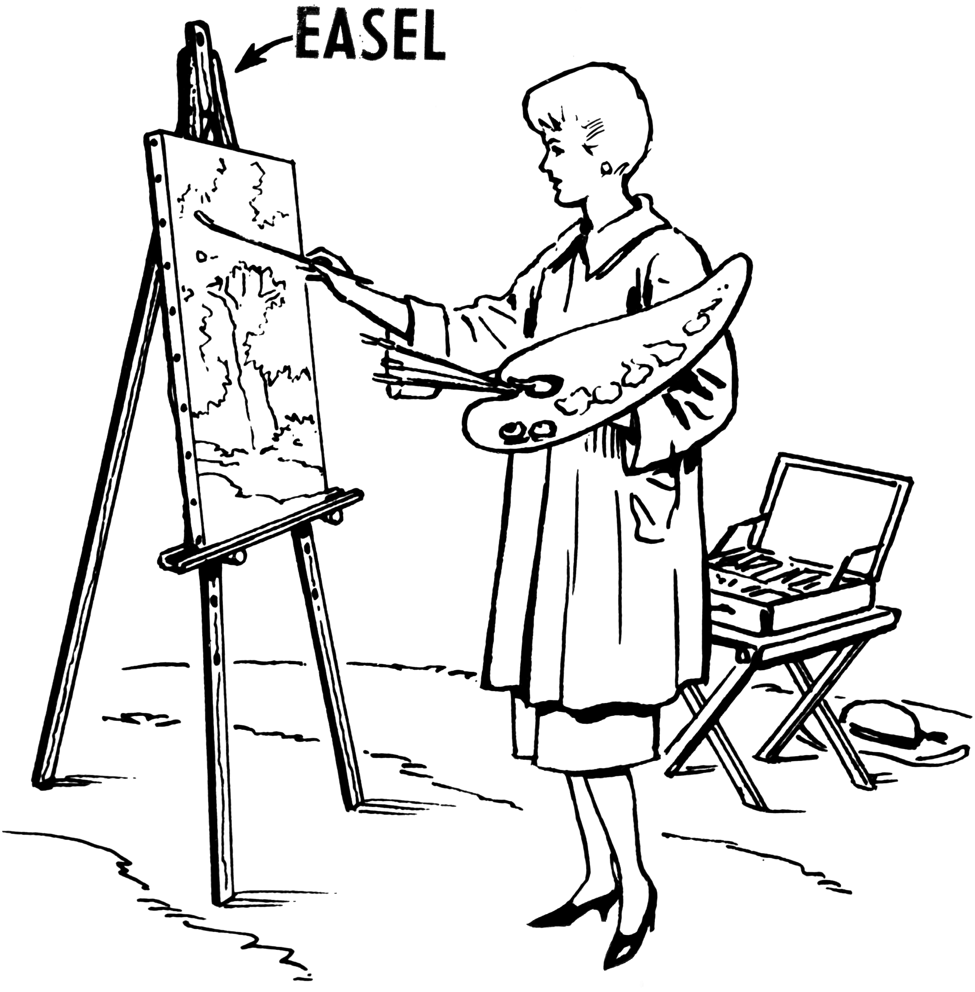
ART DESIGN

History

Chronological Understanding
- Uses timelines to place events in order
- Understands timeline can be divided into BC and AD
- Uses words and phrases: century, decade
Knowledge and Understanding of Past Events, People and Changes in the Past
- Uses evidence to describe past: houses and settlements; culture and leisure activities’ clothes which people wore; buildings and their uses; people’s way of life; people’s beliefs and attuites; things of importance to people; the differences between the lives of rich and poor in society
- Uses evidence to find out how any of these may have changed during a time period
- Describes similarities and differences between people, events and objects
- Shows changes on a timeline
Historical Interpretation
- Looks at 2 versions of the same event and identifies differences in the accounts and understands why differences may occur
Historical Enquiry
- Uses printed sources, the internet, pictures, photos, music, artefacts, historic buildings and visits to collect information about the past
- Ask questions such as ‘how did people…? What did people do for…..?
- Suggests courses of evidence to use to help answer questions
Organisation and Communication
- Presents findings about past using speaking, writing, ICT and drawing skills
- Uses dates and terms with increasing accuracy
- Discusses different ways of presenting information for different purposes

Geographical Skills & Fieldwork
- Ask and respond to geographical questions. For example, describe the landscape, why is it like this? How have people been affected? What do you think it might be?
- Analyse evidence and draw conclusions e.g. make comparisons between locations using various sources
- Recognise that different people may hold different views about a place and what is happening to it than other people
- Communicate findings in ways appropriate to the task or for the audience
- Understand and use a widening range of geographical terms linked to the geographical focus of the journey e.g. meander, floodplain, location, industry, transport, water cycle etc.
- Make more detailed fieldwork sketches/diagrams
- Use and interpret maps, globes, atlases to locate countries and their key features
- Use four figure grid references
- Use the 8 points of a compass (N, NE etc)
- Make plans and maps using symbols
and keys
Locational Knowledge
- Identify where counties are within the UK
- Be able to identify South East England, London and specifically Kent and Hoo Peninsula in relation to the rest of the country and mainland Europe
Human and Physical Geography
- Identify physical and human features of the locality
- Explain about weather conditions/patters around the UK and parts of Europe
Place Knowledge
- Recognise that there are similarities and differences between places – local examples should be used
- Develop an awareness of how places relate to each other: London as a workplace but live in Kent etc
Geography
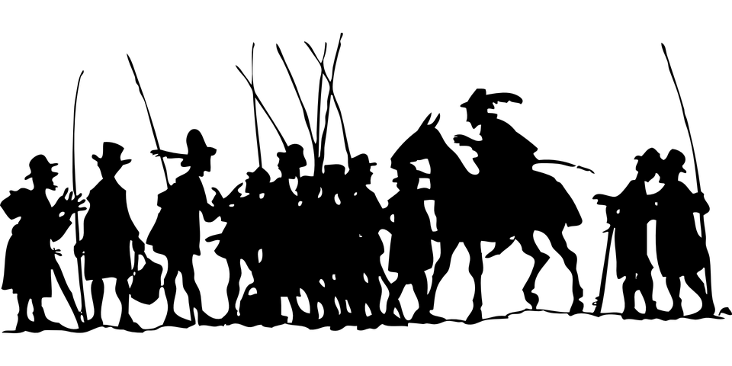

Working Scientifically
- Ask relevant questions and use different types of scientific enquiries to answer them
- Set up simple practical comparative and fair tests
- Make accurate observations and measurements using a range of measuring equipment
- Gather, record, classify and present data in a variety of ways
- Record findings using simple scientific language, drawings, labelled diagrams, graphs and tables
- Report conclusions of investigations and display results in written and visual form
- Use results to make simple conclusions, make predictions, suggest improvements to testing methods
- Identify differences, similarities or changes relating to simple scientific ideas and processes
Animals including Humans
- Identify that humans and some animals have skeletons and muscles for support, protection and movement
- Identify that animals, including humans, need the right types and amount of nutrition
Plants
- Identify and describe the functions of different types of flowering plants: roots, stem/trunks, leaves, flower
- Explore the requirements of plants for life and growth (air, light, water, nutrients, space) and how they vary from plant to plant
- Investigate the way in which water is transported within plants
- Explore the part that flowers play in the life-cycle of flowering plants, including pollination, seed formation and seed dispersal
Forces and Magnets
- Compare how things move on different surfaces
- Understand that some forces need contact between two objects but that magnetic forces can act at a distance
- Identify and group magnetic and non-magnetic materials
- Observe how magnets attract or repel each other and attract some materials and not others
- Describe how magnets have two poles
- Predict if magnets will attract or repel each other based on the poles facing each other
Light
- Notice that light is reflected from surfaces
- Recognise that light is needed to see things and that dark is the absence of light
- Recognise the dangers of sunlight and how the eyes can be protected
- Recognise that shades are formed when the light from a light source is blocked by a solid object
- Find patters in the way that the size of shadows change
Rocks
- Recognise that soils are made from rocks and organic matter
- Describe in simple terms how fossils are formed when living things become trapped within rock
- Compare and group together different kinds of rock in basis of their appearance and physical properties

Listening
- Recognise words and phrases heard by responding appropriate
- Follow simple instructions and link pictures or actions to language
- When listening to stories, rhymes or songs, join in with repeated sections and identify particular phonemes and rhyming words
- Speaking
- Ask and answer simple questions
- Repeat sentences heard and make simple adaptations to them
- Use mostly accurate pronunciation and speak clearly when addressing an audience
- Use simple objectives such as colours and sizes to describe things orally
- Reading
- Recognise some familiar words and phrases in written form
- Read some familiar words aloud using mostly accurate pronunciation
- Learn and remember new words encountered in reading
- Writing
- Write some single words from memory
- Use simple adjectives such as colours and sizes to describe things in writing
- Record descriptive sentences using a word bank
- Grammar
- Recognise the main word classes e.g. nouns, adjectives and verbs
- Understand that nouns may have different genders
- Have a basic understanding of the usual order of words in sentences
Science

MFL
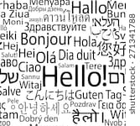
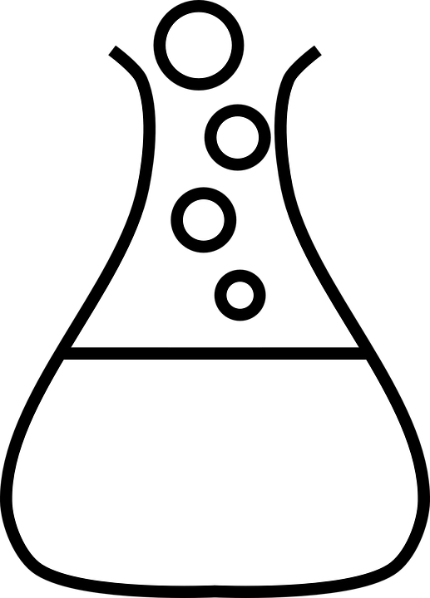

- Explain risk of communicating online with others I don’t know well
- Explain the difference between “knowing” someone online and “trusting” them online
- Recognise need to be careful about sharing anything about myself online
- Know who to ask if unsure whether to post something online
- I can describe and explain some rules for keeping my information private
- I cane explain how many devices in my home could be connected to the internet and can list some of these devices
Net Searching
- Search information about myself online
- Use simple search technologies to find web pages
- I can describe what voice activated searching is and how it might be used – Alexa, Siri
- Understand that not all websites are reliable as others
Coding
- Design, write and debug programs that complete a given task
- Explain how simple algorithms solve a problem given
Self-Image & Identity / Copyright & Ownership
- I can explain what is meant by the term identity
- I can explain how I can represent myself in different ways online
- I can explain ways in which I might change my identity depending on what I am doing online – gaming avatar, appropriate social media, working at school
- I can describe why other peoples work belongs to them
- I can recognise that content on the internet may belong to other people

Computers
- Recognise input and output devices and how they are used
- Use a range of input and output devices efficiently
Networks
- Understand that computer network allows the sharing of data and information
- Understand that the internet is a network of computers and that information can be shared between the computers
Using a Computer
- With support select and use a variety of software to achieve a given task
- Give examples of specific technology communication (emoji’s, text speak etc)
- Describe ways people who have similar interests can get together online
E-Safety
- Can explain what bullying is and can describe how people may bully others
- Can describe rules about how to behave online and how to follow them
- Can identify some online technologies where bullying may take place
- I can use appropriately secure passwords to keep my accounts and devices secure
- Use technology safely and respectfully, keeping personal data private
- Use technology safely and recognise acceptable and unacceptable behaviour
- Explain why I should be careful who I trust online and what information I should trust with them
- Explain what it means to “know” someone online and how this might be different to knowing someone in real life

Computing Continued
Computing



