RE


Beliefs and Teachings
- Develop religious and moral vocabulary to describe key features and know beliefs, ideas and teachings for some religions
Religious Practices and Lifestyles
- Know the function of objects, places, people within religions studied
- Describe similarities and differences in Religious practices and lifestyles both within and between religions
Ways of Expressing Meaning
- Begin to understand the impact of religious teachings, including the effect sacred texts have on believers’ lives
- Identify religious symbols and how they may be interpreted in different ways both within and between religions
Human Identity, Personality and Experience
- Recognises what influences my life and identify the influence religion has on lives and communities including my own
Questions of Meaning and Purpose
- Start to develop simple answers based on own views and experience to some of the ultimate questions discussed
Values and Commitments
Begin to ask important questions about how religious and moral values, commitments and beliefs can influence behaviour

Cooking & Nutrition
- Understand what makes a healthy and balanced diet and that different foods and drinks provide different substances a body needs to remain active
- Understand that certain foods are of a seasonal nature and the benefits of eating seasonal and locally produced foods
- Read and follow recipes which follow several different processes, skills and techniques.
Processes
- Use knowledge of existing products to design a functional and appealing product for a particular purpose and audience
- Create designs using exploded designs
- Use techniques which require more accuracy to cut, shape, join and finish my work e.g. cut internal shapes, create slots for fixtures
- Use knowledge of techniques and the functional qualities of a wide range of materials to plan how to use them
- Consider how products can be improved to better match the intended use or user
- Apply techniques I have learnt to strengthen structures
- Understand and use electrical systems in products
Learning
- Use a sketchbook for collecting ideas and developing a plan for a completed piece of work
- Use taught technical skills to adapt and improve my work
- Articulate how I might improve my work using technical terms and reasons as a matter of routine
- Describe some of the key ideas, techniques and working practices of artists, architects and designers who I have studied
Techniques
- Draw familiar objects with correct proportions
- Create different effects by using a variety of tools and techniques such as bleeds, washes, scratches and splashes
- Plan a sculpture through drawing and other preparatory work
- Experiment with creating mood, feeling, movement and areas of interest by selecting appropriate materials and learnt techniques
- Use a variety of techniques e.g. marbling, silkscreen and cold-water paste
- Print on fabrics using tie-dyes or batik.

Hoo Progression Steps – Year 4

DT
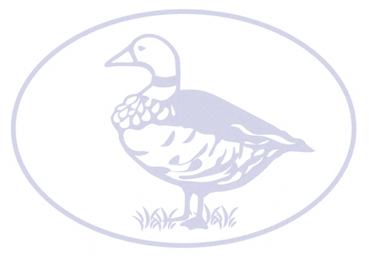
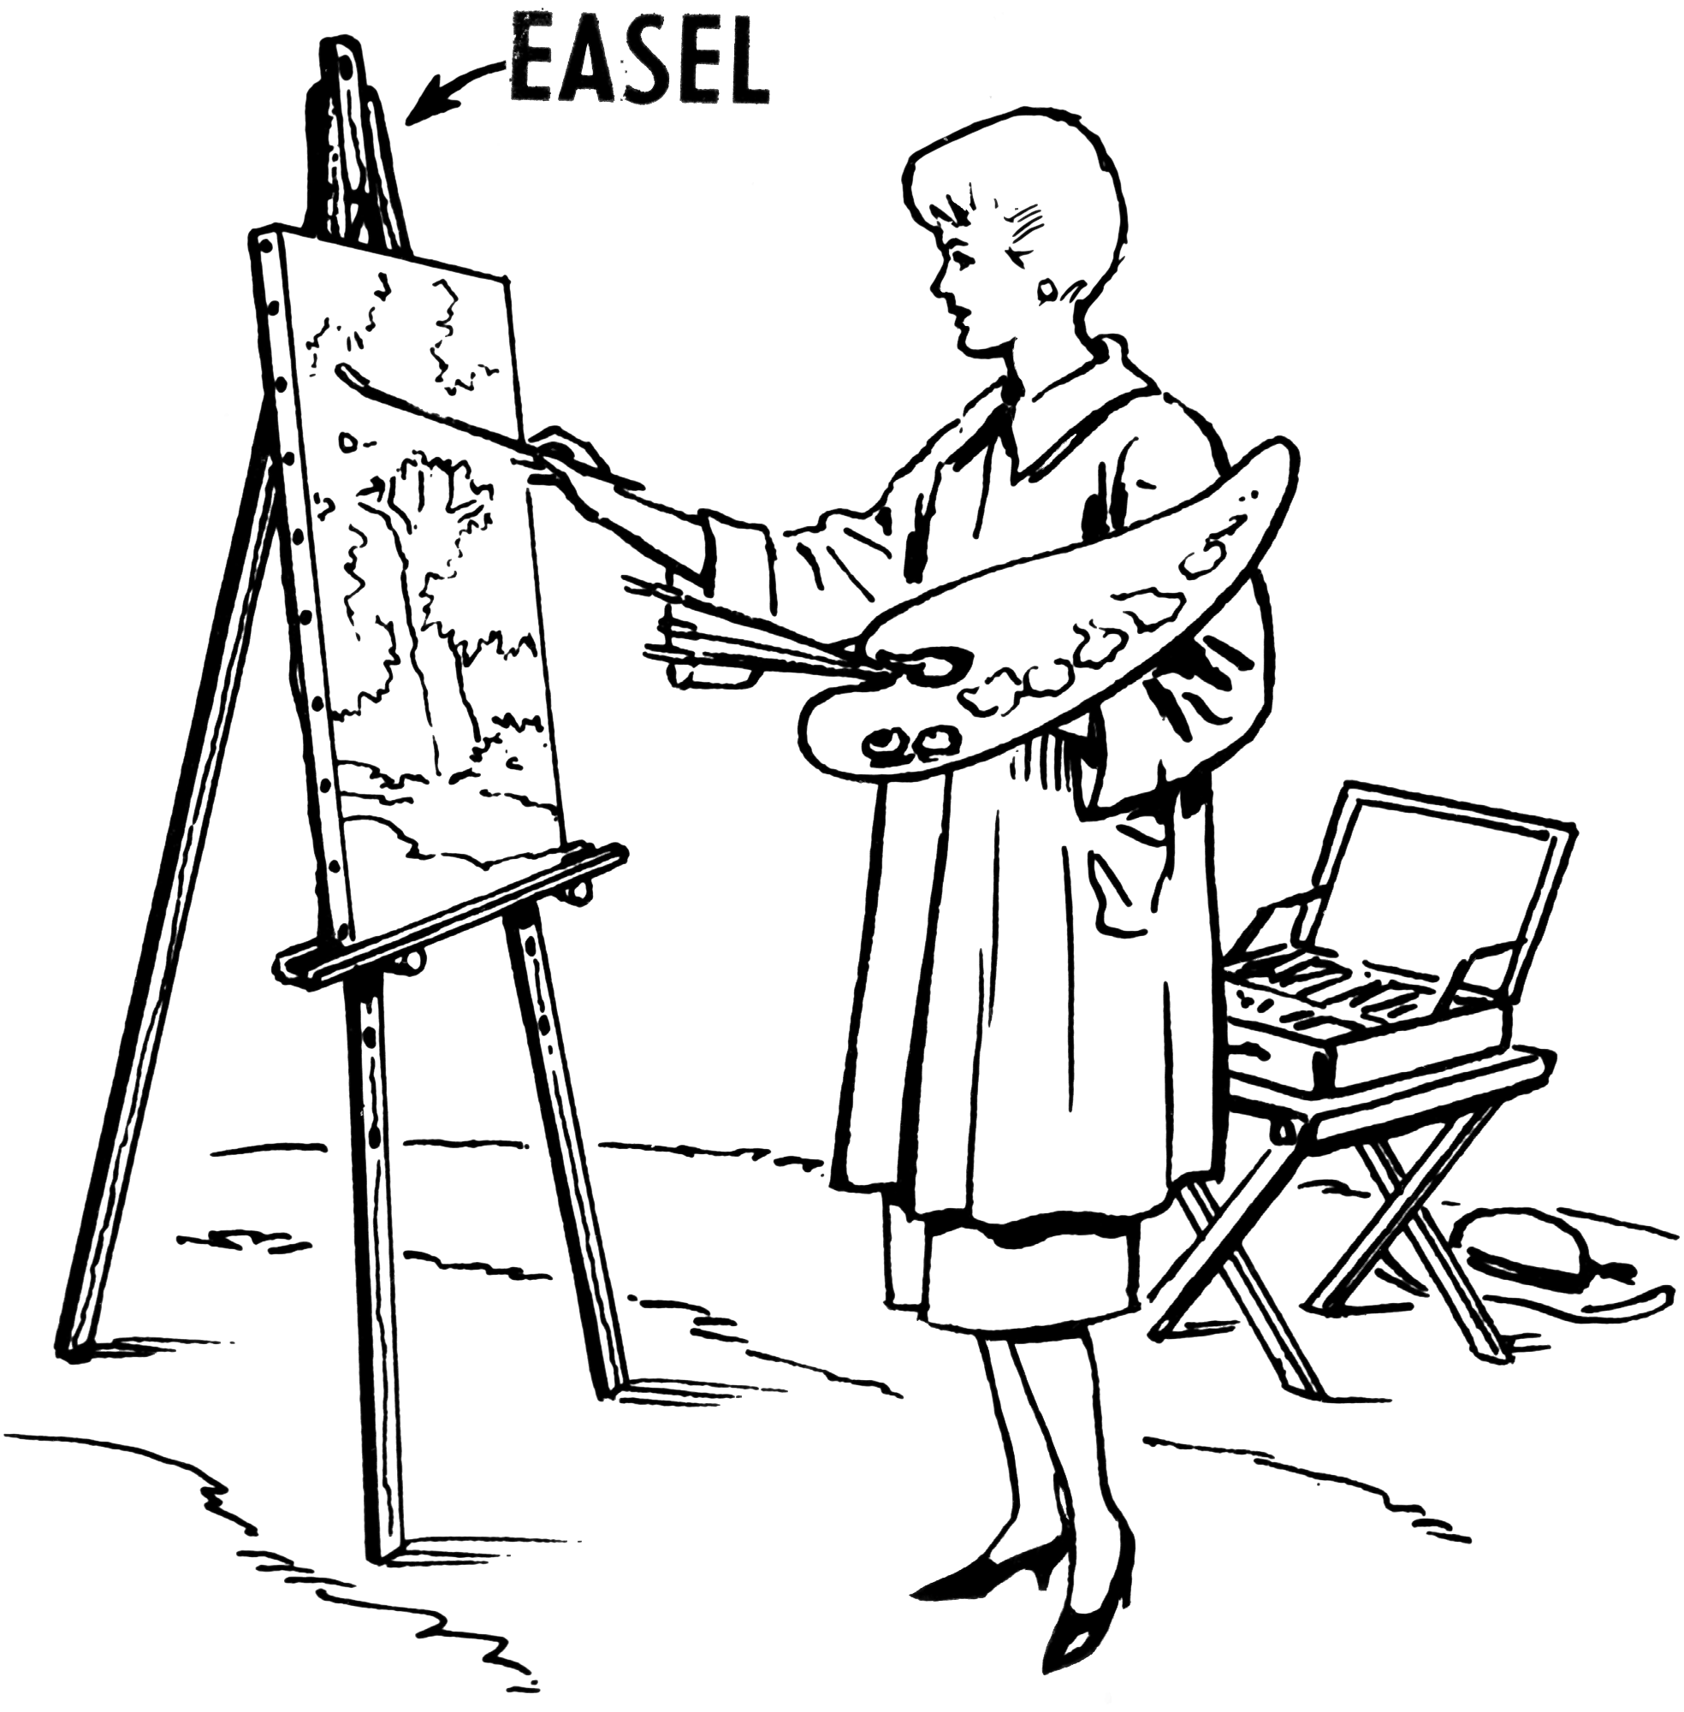
- Confidently recognise a range of musical instruments and the different sounds they make
- Confidently recognise and explore a range of musical styles and traditions and know their timbre, texture, rhythm characteristic
- Use appropriate musical language to appraise a piece of style of music
- Copy increasingly challenging rhythms using body percussion and untuned instruments where appropriate
- Sign as part of an ensemble with confidence and precision
- Play and perform in solo or ensemble contexts with increasing confidence
- Develop an understanding of formal, written notation which includes minims and quavers
- Listen to and recall sounds with increasing aural memory

ART DESIGN

Music

Chronological Understanding
- Use words and phrases: century, decade, BC, AD, after, before, during
- Divides recent history into present, using 21st century and the past using 19th and 20th centuries
- Able to names and places dates of significant events from past on a timeline
Knowledge and Understanding of Past Events, People and Changes in the Past
- Shows knowledge and understanding by describing features of past societies and periods.
- Identifies some ideas, beliefs, attitudes and experiences of men, women and children from the past
- Give reasons why changes in houses, culture, leisure, clothes, buildings and their uses, things of importance to people, ways of life, beliefs and attitudes may have occurred during a time period.
- Describes how some of the past events/people affect life today
Historical Interpretation
- Gives reasons why there may be different accounts of history
Historical Enquiry
- Understands the difference between primary and secondary sources of evidence.
- Uses documents, printed sources, the internet, databases, pictures, photos, music, artefacts, historic buildings and visits to collect information about the past
- Asks questions such as ‘what was it like for ….. during …..?
- Suggests sources of evidence form a selection provided to use to help answer questions.
Organisation and Communication
- Presents findings about past using speaking, writing, maths (data handling), ICT, drama and drawing skills
- Uses dates and terms correctly
- Discusses most appropriate way to present information, realising that it is for an audience
- Uses subjection specific words such as monarch, settlement, invader

Geographical Skills & Fieldwork
- Understand and use a widening range of geographical terms relevant to Learning Journey – contour, height, erosion, deposition, headland, volcanoes, earthquakes
- Explore features on an OS maps using 6 figure grid references
- Draw accurate maps using more complex keys
- Plan the steps and strategies for an enquiry which answers a specific question
Locational Knowledge
- Recognise the difference shapes of continents
- Understand how all continents used to be joined and how this can be seen in current shape of continents
- Recognise that people have differing quality of life living in different locations and environments
- Recognise that inequality can be seen in our local community
- Understand that the Hoo Peninsula is set within a wider geographical context
Human and Physical Geography
- Understand the effect of landscape features on the development of our local area including the effect of the River Medway
- Describe how people have been affected by changes in the environment: changes to land use, changing position of River Medway
- Describe how people have been, or may be, affected by changes to the local community of Hoo expansion, building works, changes to transport links
- Explore weather patterns around the parts of the world
- Understand how the weather of the South East may be affected by climate change
Place Knowledge
- Understand how the local area fits into the wider context of county, region, country
- Understand why there are differences between the local area and another area within the South-East
- Understand how the South-East is different to another region of the UK in terms of physical geography
History
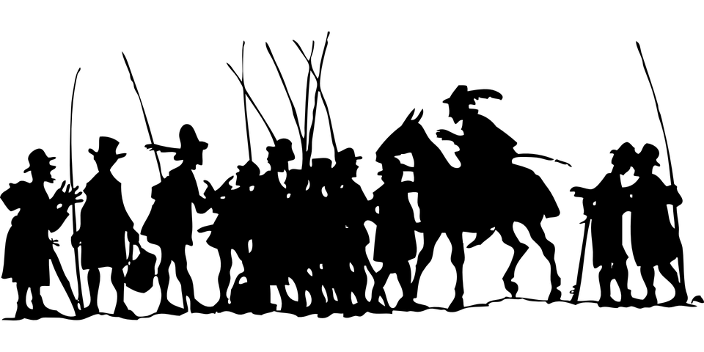
Geography

Listening
- Show understanding of a range of familiar spoken phrases
- Listen to and accurately repeat the sounds heart in songs and rhymes
- Notice that the language studied may contain different phonemes and that some similar sounds may be spelt differently to English
Speaking
- Ask and answer a range of questions on different topic areas
- Change simple sentences in different ways to make new sentences
- Read aloud using accurate pronunciation and present a short-learned piece of performance
Reading
- Understand and read out several familiar phrases and sentences accurately
- Follow the written version of a text being listened to
- Begin to work out the meaning of unfamiliar words within a familiar text using contextual and other clues.
Writing
- Write short words and phrases from memory
- Use a range of adjectives to describe things in more detail, such as describing someone’s appearance
- Write descriptive sentences using a model but supplying some words from memory
Grammar
- Recognise a wider range of word class including pronouns and articles and use them appropriately
- Understand that adjectives may change according to the noun they relate to, and select the appropriate form
- Recognise questions and negative sentences
MFL
Working Scientifically
- Ask relevant questions and use different types of scientific enquiries to answer them
- Set up simple practical comparative and fair tests
- Make careful observations and take accurate measurements using a range of equipment
- Gather, record and present data in a variety of ways to help with answering questions
- Record findings using simple scientific language, drawings, labelled diagrams, keys, bar charts and tables
- Use results to draw simple conclusions, make predictions for new values, suggest improvements and raise further questions
- Identify differences, similarities or changes related to simple scientific ideas and processes
- Use straightforward scientific evidence to answer questions to support findings
Animals including Humans
- Describe the simple functions of the basic parts of the digestive system in humans
- Identify the different types of teeth in humans and their simple functions
- Construct and interpret a variety of food chains, identifying produces, predators and prey
Electricity
- Identify common appliances that run on electricity
- Construct a simple series electrical circuit, identifying and naming its basic parts, including cells, wires, bulbs, switches and buzzers
- Identify whether or not a lamp will light in a simple series circuit, based on whether or not the lamp is part of a complete loop with a battery
- Recognise that a switch opens and closes a circuit and associate this whether or not a lamp lights in a simple series circuit
- Recognise some common conductors and insulators, and associate metals with being good conductors
Living Things and Their Habitats
- Recognise that living things can be grouped in a variety of ways
- Explore and use classification keys to help group, identify and name a variety of living things in their local and wider environment
- Recognise that environments can change and that this can sometimes pose dangers to living things
Sound
- Identify how sounds are made, associating them with something vibrating
- Recognise that vibrations from sounds travel through a medium to the ear
- Find patterns between the pitch of a sound and features of the objects that produce it
- Find patterns between the volume of a sound and the strength of the vibrations that produced it
- Recognise that sounds get fainter as the distance from the sound source increases
State of Matter
- Compare and group materials together, according to whether they are solids, liquids or gases including tricky ones such as paste, gels, mist, foams
- Observe that some materials change state when they are heated or cooled, and measures or research the temperature at which this happens in degrees Celsius
- Identify the part played by evaporation and condensation in the water cycle, and associate the rate of evaporation with temperature

Science

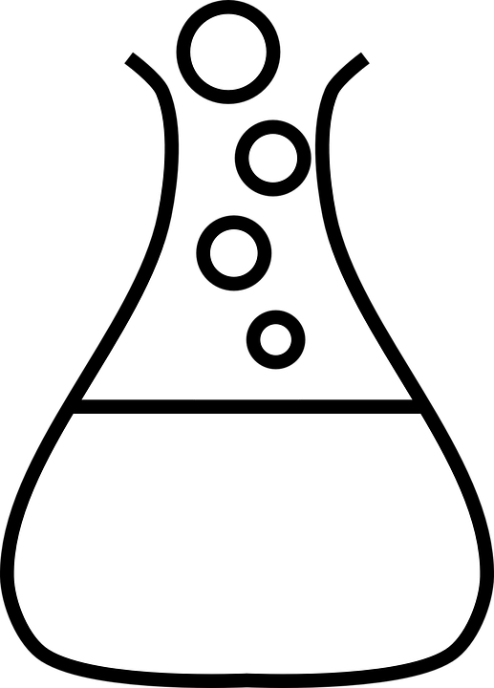
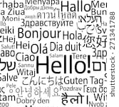
Computing
Computing Continued

- I can suggest reasons why they might do this – fraud, being unkind, finding out about me and my friends, get to others through my contacts
- Know what to do and who to go to if I see something online which worries me
- Explain how others can find information about me by looking online
- I can explain what a strong password is
- I can describe simple strategies for creating and keeping passwords private
- I know what to do if my password is lost or stolen
- Explain how some of the information about me online could have been created, copied or shared by others
- I can explain how and why some apps may request or take payment for additional content (in-app purchases) and explain why I should seek permission from a trusted adult before purchasing.
- I can explain the differences between things which are made up and things which are true
Net Searching
- Understand how results are selected and ranked by search engines
Coding
- Break programs up into smaller parts
- Use logical thinking to identify and solve potential bugs during coding
- Select and combine a variety of software, systems and content to achieve a task
Self-Image & Identity / Copyright & Ownership
- I can explain how my online identity can be different to the identity I present in “real life”
- I can describe how to make the right decisions about how I interact with others and how others perceive me
- I can explain why copying someone else’s work from the internet without permission can cause problems
- When searching on the internet for content to use, I can explain why I need to consider who owns it and whether I have the right to reuse it
- I can give examples of what those problems might be
Online relationships
- Give examples of how to be respectful to others online
- Make positive contributions to online communities

Computers
- Use a range of input devices such as cameras or sensors
Networks
- Understand what servers are and how they help a network achieve tasks such as controlling printers, help sharing files, communicate with other machines
Using a Computer
- With support select and use a variety of software on a range of digital devices
- Describe strategies for safe and fun experiences in a range of online social environments
- With support select, use and combine a variety of software on a range of digital devices to accomplish given goals
- I can explain why spending too much time using technology can sometimes have a negative impact on me
- I can explain how using technology can distract me from other things I might do or should be doing
- I can identify times or situations when I might need to limit the amount of time I use technology
E Safety
- Explain how to block users who are upsetting me
- Can describe ways people can be bullied through a range of media – image, chat, video, text
- Can explain why I need to think carefully about how content I post might affect others
- Recognise when someone is upset, hurt or angry online
- Describe how to get help or someone that is being bullied online and decide if I need to tell somebody else
- Use technology responsibly and understand that communication online may be seen, copied and shared by others without me knowing.
- Explain that there may be people online who want to do me or my friends harm
- Recognise that it is not my fault if people want to do me or my friends harm
- I can explain that others online may pretend to be me or other people, including my friends

