Beliefs and Teachings
Identify and discuss the important features of the religions taught
Religious Practices and Lifestyles
- Identify and describe similarities and differences in Religious practices and lifestyles both within and between religions
Ways of Expressing Meaning
- Begin to understand the impact of religious teachings, including the effect sacred texts have on believers’ lives
- Identify religious symbols and how they may be interpreted in different ways both within and between religions
Human Identity, Personality and Experience
- Ask questions of identity and belonging and suggest own answers about the significant experiences of others, including religious believers
Questions of Meaning and Purpose
- Raise questions and suggest religious, philosophical and moral answers to a range of ultimate questions raised by the religions studied
Values and Commitments
- Ask questions about matter of right and wrong identify how different beliefs can influence the decisions people may make

Cooking & Nutrition
- Understand the main food groups and the different nutrients that are important for health.
- Understand how a variety of ingredients are grown, reared, caught and processed to make them safe and trusty to eat
- Select appropriate ingredients and use a wide range of techniques to combine them.
Processes
- Use research into existing products to inform the design of my own innovative product
- Create prototypes to show my ideas
- Make careful and precise measurements to that joins, holes and openings are in exactly the right place
- Produce step by step plans to guide the making of products
- Make details evaluations about products I have made
- Make detailed evaluations about products others have made bearing in mind their views and feelings
- Build more complex 3D structures and use skills to strengthen them and make them more stable
- Understand how to use more complex mechanical and electrical systems
RE

Learning
- Develop different ideas which can be used and explain my choices for the materials and techniques used
- Confidently and systematically investigate the potential of new and unfamiliar materials and use these learnt techniques in my work
- Evaluate my work against the intended outcomes
- Research and discuss various artists, architects and designers and discuss their processes and explain how these were used in the finished products
Techniques
- Use line, tone and shading to represent things seen, remembered or imagined in three dimensions
- Mix colours to express mood, divide foreground from background or demonstrate tones
- Develop skills in using clay including slabs, coils and slips
- Add collage to a painted, drawn or printed background using a range of media, different techniques, colours and textures
- Experiment with using layers and overlays to create new colours and textures
- Return to work over long periods of time and uses a wider range of materials

Hoo Progression Steps – Year 5

DT

- Compose complex rhythms for an increasing aural memory
- Understanding how pule, rhythm and pitch work together
- Improvise with increasing confidence using own voice, rhythms and varied pitch
- Sing as part of an ensemble with increasing confidence and precision
- Play and perform in solo or ensemble contexts with some accuracy, control, fluency and expression
- Use and develop an understanding of formal, written notation which includes staff, semibreves and dotted crotchets
- Develop an increasing understanding of the history and context of music
- Listen with attention to detail and recall sounds with increasing aural memory

ART DESIGN

Music
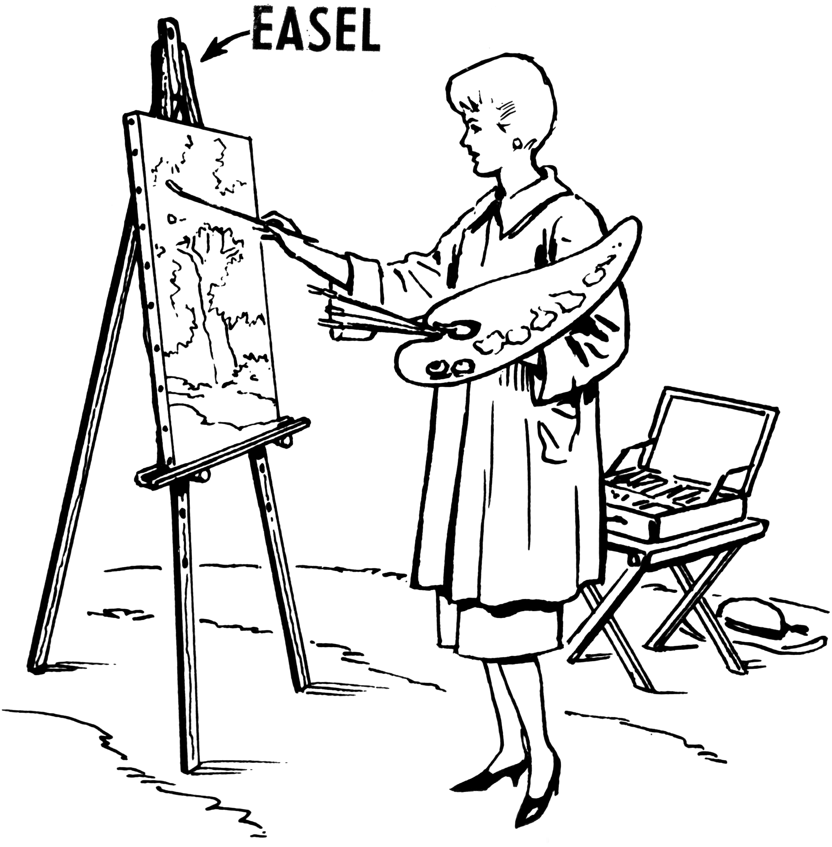

Chronological Understanding
- Uses timelines to place and sequence local, national and international events
- Sequences historical periods.
- Describes events using words and phrases such as: century, decade, BC, AD, after, before, during Tudors, Stuarts, Victorians, era, period.
- Identifies changes within and across historical periods.
Knowledge and Understanding of Past Events, People and Changes in the Past
- Identifies some social, cultural, religious and ethnic diversities of societies studied in Britain and wider world.
- Gives some causes and consequences of the main events, situations and changes in the periods studied.
- Identifies changes and links within and across the time period studied.
Historical Interpretation
- Looks at different versions of the same event and identifies differences in the accounts
- Gives clear reasons why there may be different accounts of history
- Evaluate the usefulness of a variety of sources
- Knows that people (now and in the past) can represent events or ideas in ways that persuade others.
Historical Enquiry
- Uses documents, printed sources, the internet, databases, pictures, photos, music, artefacts, historic buildings and visits to collect information about the past.
- Asks a range of questions about the past
- Chooses reliable sources of evidence to answer questions
- Realises that there is often not a single answer to historical questions.
Organisation and Communication
- Presents structured and organised findings about the past using speaking, writing, maths, ICT, drama and drawing skills
- Uses dates and terms accurately
- Chooses most appropriate way to present information to an audience

Geographical Skills & Fieldwork
- Understand and use a widening range of geographical terms appropriate to the Learning Journey
Locational Knowledge
- Identify and describe the significance of the Greenwich Meridian and time zones
- Identify the physical characteristics of countries studied in Learning Journeys
- Know location of: Capital cities of countries studied in the Learning Journeys
- Know location of: capital cities of countries of the UK, capital cities of countries studied as part of Learning Journeys
Human and Physical Geography
- Understand about world either patters around the World and relate these to climate zones
- Know how rivers road, transport and deposit materials
- Know about the physical features of the coats and begin to understand erosion and deposition
- Understand how humans have affected the local environment over time
- Know about changes to world environment over time
- Understand how people seek to manage and sustain their environment
Place Knowledge
- Compare the physical and human features of a region of the UK and a region in North America, identifying similarities and differences.
History
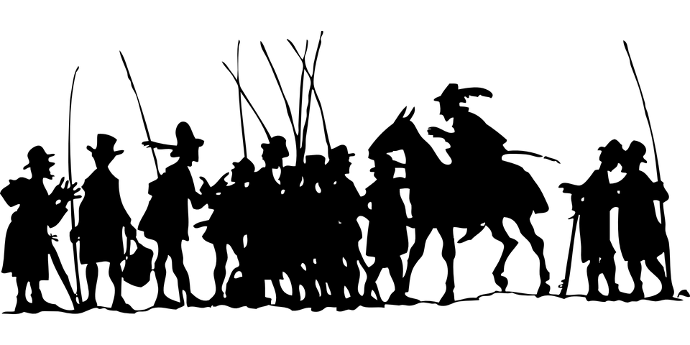
Geography

Listening
- Understand the main points from a spoken passage
- Match the spoken version of most words to the correct spelling
Speaking
- Take part in conversations and express simple opinions giving reasons
- Make changes to a complex sentence I have heard to create a new sentence with a different meaning
- Use intonation to differentiate between asking a question or making a statement
- Create and deliver a short speech in front of an audience
Reading
- Read aloud and understand a short text containing most familiar language, using fairly accurate pronunciation
- Learn a song or poem using the written text for support
- Use dictionaries to extend vocabulary on a given topic and develop ability to use different strategies to work out the meaning of unfamiliar words
Writing
- Write phrases and simple sentences from memory
- Use different adjectives to describe people and things and use some verbs to describe actions
Grammar
- Know the different forms of some common verbs and when to use each form
- Understand how to make changes to an adjective in order for it to “agree” with the relevant noun
- Adapt sentences to form negative sentences and to begin to form questions
MFL
Working Scientifically
- Plan different types of scientific enquiries to answer questions, including recognising and controlling variables where necessary
- Take accurate measurements using a range of scientific equipment, taking repeat readings when necessary
- Record data and results of increasing complexity, using diagrams and labels, tables, scatter graphs, bar and line graphs
- Use test results to make predications to set up further comparative and fair tests
- Discuss the accuracy of results and how reliable the information is
- Identify scientific evidence that has been used to support or refute ideas or arguments.
Animals including Humans
- Describe eh changes as humans develop into old age
Materials
- Compare and group together everyday materials on the basis of their properties, including their hardness, solubility, transparency, conductivity (electrical and thermal) and response to magnets
- Recognise that some materials will dissolve in liquids to forma solution, and describe how to recover a substance from a solution
- Use knowledge of solids, liquids and gases to decide how mixtures might be separated, including by filtering, sieving and evaporating.
- Give reasons based on evidence from comparative and fair test, for the particular uses of everyday materials, including metals, wood and plastic
- Demonstrate that dissolving, mixing and changes of state are reversible changes
- Explain that some changes result in the formation of new materials and that this kind of change is not usually reversible, including changes associated with burning and acids
Forces and Magnets
- Explain that unsupported objects fall towards the Earth because of the force of gravity
- Identify the effects of air resistance, water resistance and friction, that act between moving surfaces
- Recognise that some mechanisms, including levers, pulleys and gears, allow a smaller force to have a greater effect
Earth & Space
- Describe the movement of the Earth, and other plants, relative to the Sun in the solar system
- Describe the movement of the moon relative to the earth
- Describe the sun, earth and moon as approximately spherical bodies
- Use the idea of the Earth’s rotation to explain day and night and the apparent movement of the sun across the sky
Living Things and Their Habitats
- Describe the differences in the life-cycles of a mammal, an amphibian, an inspect and
a bird
- Describe the life processes of reproduction in some plants and animals

Science


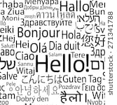
Computing
Computing Continued


- Demonstrate how I would support others having difficulties online
- Demonstrate ways of reporting problems online for myself and friends
- I can explain how many free apps or services may read and share my private information (friends, contacts, likes, images, videos, voice messages, geolocation etc) with others
- I can explain what app permissions are and can give examples from the technology or services I use
- Understand the need to only select age appropriate content.
Net Searching
- Use filters and more advanced features when searching online
- Use filters when searching and appreciate how resulted are selected and ranked
- Search for information about an individual online and create a summary report of the information I find
- Describe how information about people online can be used by others to make judgements about an individual.
Coding
- Design, input and test increasingly complex programmes to achieve a given task
- Design, write and debug programs that accomplish specific goals, including controlling or simulating physical systems
- Design, write and test simple programs which incorporate repeating loops allowing actions to be repeated for a set number of times
- Design, write and test programs where the end result is determined by actions earlier in the program by using effective sequencing instructions
- Explain how complex algorithms solve a given problem
Self-Image & Identity / Copyright and Ownership
- Explain how identity online can be copied, modified or altered
- Demonstrate responsible choices about online identity depending on the context being used
- Demonstrate how media can shape ideas about gender
- Identify messages about gender roles and make judgements about the messages being given
- I can assess and justify when it is acceptable to use the work of others

Networks
- Use the internet to share data with another person.
Using a Computer
- Select appropriate software to use for a given task
- Independently select, use and combine a variety of software to design and create content for a given audience
- I can describe ways technology can affect healthy sleep and describe some of the issues
- I can describe common systems that regulate age-related content (PEGI, BBCF, Parental Warnings) and describe their purpose
- I can describe some strategies, tips or advice to promote healthy sleep with regards to technology
- I can action different strategies to limit the impact of technology on my health (night-shift mode, regular breaks, correct posture, sleep, diet, exercise)
- I can explain the importance of self-regulating my use of technology for example, through monitoring my time online
E-Safety
- I can use different passwords for a range of online services
- I can describe effective strategies for managing my passwords (e.g. password managers, acronyms, stories)
- Can explain how to block abusive users
- Describe the helpline services who can support me and what I would say and do if I needed their help
- Describe how to capture bullying content as evidence e.g. screen-grab, to share with people who can help me
- Identify a range of ways to report concerns both in school and at home about online bulling
- Explain how I would report online bullying on the apps and platforms I use
- Understand responsibility for the well-being of others in shared online social groups
- Explain how rash and impulsive communications online may cause problems for myself and others

