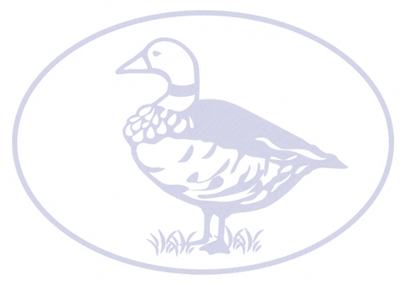
- Sing as part of an ensemble with full confidence and precision
- Play and perform in solo or ensemble contexts with increasing accuracy, control, fluency and expression
- Create a simple composition and record using formal notation
- Develop a deeper understanding of the history and context of music
- Appropriately discuss the dimensions of music and recognise them in music heard
- Listen with attention to detail and recall sounds with increasing aural memory and accuracy
- Appreciate and understand a wide range of high-quality live and recorded music drawn from different traditions and from great composers and musicians.
- Deepen an understanding and use of formal, written notation which includes staff, semibreves and dotted crotchets
- Improvise and compose music for a range of purposes using the inter-related dimensions of music

Beliefs and Teachings
- Begin to use some philosophical language and increasingly wide religious and more vocabulary to explore and suggest some reason for the similarities and differences in beliefs and teaching both within and between religions.
Religious Practices and Lifestyles
- Explain how and why religions have different views on how people should live their lives
Ways of Expressing Meaning
- Explain the reasons for diverse forms of expression in religious teachings, including sacred texts, both within and between religions.
Human Identity, Personality and Experience
- Discuss personal views about the different religions studied in KS2 and discuss how I feel people should live their lives.
Questions of Meaning and Purpose
- Explain personal views about a range of important religious issues and respectfully discuss the views of others
Values and Commitments
- Argue intelligently about religion and beliefs

Music
DT
RE
ART DESIGN

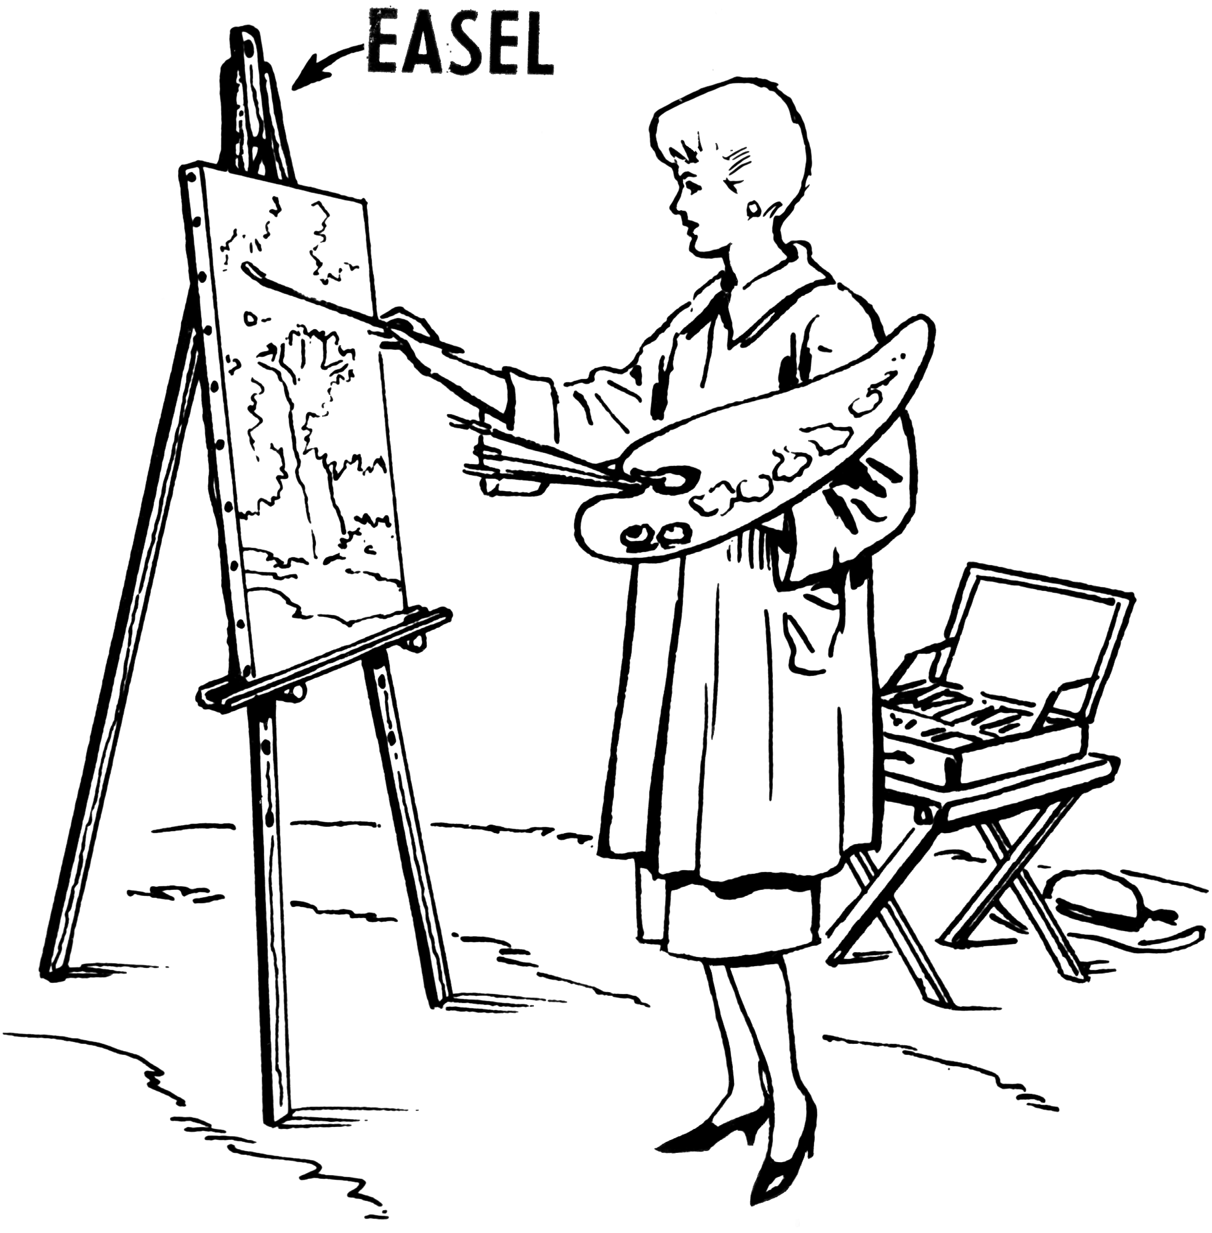
Learning
- Select ideas based on first hand observations, experience or imagination and develop these through open ended research
- Refine my use of learnt techniques
- Adapt my final work following feedback or discussion based on my preparatory ideas
- Describe the work and ideas of various artists, architects and designers, using appropriate vocabulary and referring to historical and cultural contexts
- Explain and justify preferences towards different styles and artists
Techniques
- Beware to develop an awareness of composition, scale and proportion in my work
- Use simple perspective in my work using a single focal point and horizon
- Use techniques, colours, tones and effects in an appropriate way o represent things seen – brushstrokes following the direction of the grass, stippling to pain sand, watercolour bleeds to show clouds
- Produce intricate patterns and textures in a malleable media
- Use different techniques, colours and textures when designing and making pieces of work and explain my choices
- Create intricate printing patterns by simplifying and modifying sketchbook designs
- Follow a design brief to achieve an effect for a particular function




Cooking & Nutrition
- Confidently plan a series of healthy meals based on the principles of a healthy and varied diet
- Use information on food labels to inform choices about having a healthy diet
- Research, plan and cook a savoury dish using my knowledge of ingredients and technical skills
Processes
- Use my research into famous designers to inform my design and be able to discuss links between them
- Generate, develop, model and communicate my ideas through discussion, annotated sketches, cross sectional drawings and exploded diagrams, prototypes, pattern pieces and computer-aided design
- Use my knowledge of techniques and materials to refine my design and product to improve its functional properties and its looks
- Use technical skills to problem solve effectively throughout the design and making process
- Use a variety of methods to strengthen, stiffen and reinforce complex structures
- Apply my understanding of computing to program, monitor and control my product
Hoo Progression Steps – Year 6
Chronological Understanding
- Uses timelines to place events, periods and cultural movements from around the world.
- Uses timelines to demonstrate changes and developments in culture, technology, region and society
- Uses these key periods as reference points: BC, AD Romans, Anglo-Saxons, Tudors, Stuarts, Georgians, Victorians and Today.
- Describe main changes in a period in history using words such as: social, religious, political, technological and cultural.
- Names dates of any significant event studied from past and place it correctly on a timeline.
Knowledge and Understanding of Past Events, People and Changes in the Past
- Chooses reliable sources of factual evidence to describe: house and settlements; culture and leisure activities; clothes, way of life and actions of people; buildings and their uses; people’s beliefs, religion and attitudes; things of importance to people; differences between lives of rich and poor
- Identifies how many of the above may have changed during a time period
- Gives own reasons why changes may have occurred, backed up with evidence
- Shows identified changes on a timeline
- Describes similarities and differences between some people, evens and objects studied
- Describes how some changes affect life today.
- Makes links between some features of the past societies.
Historical Interpretation
- Understands that the past has been represented in different ways
- Suggests accurate and plausible reason for how/why aspects of the past have been represent and interpreted in different ways.
- Knows and understands that some evidence is propaganda, opinion or misinformation and that this affects interpretations of history.
Historical Enquiry
- Identifies and uses different sources of information and artefacts
- Evaluates the usefulness and accurateness of different sources of evidence
- Selects the most appropriate source of evidence for particular tasks
- Forms own opinions about historical events from a range of sources
Organisation and Communication
- Presents information in an organised and clearly structured way
- Makes use of different ways of presenting information.
- Presents information in the most appropriate way (e.g. written explanation/tables and charts/labelled diagram)
- Makes accurate use of specific dates and terms.

Geographical Skills & Fieldwork
- Use maps, atlases, globes and digital mapping to locate countries and regions studied
- Use the eight points of a compass, four and six-figure references, symbols and keys when creating maps and interpreting maps of the areas studied.
- Use fieldwork to observe, measure, record and present the human and physical features in the local area using a range of methods including sketch maps, plans and graphs and digital technologies
- Understand and use a widening range of geographic terms e.g. specific Learning Journey vocabulary
- Use maps, charts etc to support decision making about the location of places and new development in the local area
Locational Knowledge
- Locate the world’s countries, using maps to focus on countries studied in the Learning Journey
- Identify key environmental regions, key physical and human characteristics of the countries and regions studied
- Identify the key longitude and latitude – Equator, Greenwich Meridian, Northern Hemisphere, Southern Hemisphere, Tropics of Cancer and Capricorn
Human and Physical Geography
- Describe and understand key aspects of physical geography, including: climate zones, biomes, rivers, mountains, volcanoes, earthquakes and the water cycle.
- Describe and understand key aspects of human geography, including: types of settlement and land use, economic activity including trade links and the distribution of natural resources including energy, food, minerals and water.
Place Knowledge
- Understand geographical similarities and differences through the study of human and physical geography of a region of the UK, a region in an EU country, and a region within North or South America.
Geography
History

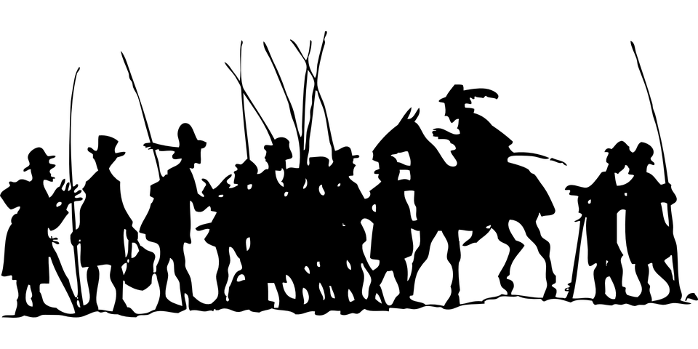
Working Scientifically
- Plan different types of scientific enquiries to answer questions, including recognising and controlling variables
- Take accurate measurements using a range of scientific equipment, taking repeat readings when necessary
- Record data and results of increasing complexity, using diagrams and labels, tables, scatter graphs, bar and line graphs
- Use test results to make predications to set up further comparative and fair tests
- Present results orally and in written form
- Identify scientific evidence that has been used to support or refute ideas or arguments.
- Describe and evaluate their own and other people’s scientific ideas related to topics studied, including ideas which may have changed over time.
- Group and classify things and recognise patterns
- Find out things using a wide range of secondary evidence
- Use appropriate scientific language and ideas to explain, evaluate and communicate methods of findings.
Animals including Humans
- Identify and name the main parts of the human circulatory system, and describe the functions of the heart, blood vessels and blood
- Recognise the impact of diet, exercise, drugs and lifestyle on the way bodies function
- Describe the ways in which nutrients and water are transported within animals, including humans
Electricity
- Associate the brightness of a lamp or the volume of a buzzer with the number and voltage of cells used in the circuit.
- Compare and give reasons for variations in how components function, including bulb brightness, buzzer volume and the on/off position of switches
- Use recognised symbols when representing a simple circuit in a diagram
- Evolution and Inheritance
- Recognise that living things have changed over time and that fossils provide information about living things that lived millions of years ago
- Recognise that living things produce offspring of the same kind, but normally offspring vary and are not identical to their parents
- Identify how animals and plants are adapted to suit their environment in different ways and that adaption may lead to evaluation.
Light
- Recognise that light appears to travel in straight lines
- Understand that things are seen as they reflect light into the eye or give out light
- Use the idea that light travels in straight lines to explain why shadows have the same shape as the objects they cast on them
Living Things and Their Habitats
- Give reasons for classifying plants and animals based on specific characteristics
- Describe how living things are classified into broad groups according to common observable characteristics and based on similarities and differences, including micro-organism, plants and animals

MFL
Listening
- Understand longer and more challenging texts on a range of topics, recognising some details and opinions heard
- Use knowledge of spelling to help me to read unfamiliar words
Speaking
- Engage in longer conversations, asking for clarification when necessary
- Create sentences using knowledge of basic sentence structure
- Use pronunciation and intonation effectively to accurately express meaning and engage an audience
Reading
- Read aloud and understand a short text containing unfamiliar words, using accurate pronunciation
- Attempt to read a range of texts independently, using different strategies to make meaning clear
- Use vocabulary learnt from reading in different contexts and use dictionaries to find a wide range of words
Writing
- Write several phrases and sentences from memory and can change them to express my own ideas
- Choose the most effective adjectives to describe people, places and things and the right verb to describe an action
- Begin to use some adverbs
Grammar
- Know when to use the correct verb form
- Understand how to use some adverbs in sentences
- Have an awareness of similarities and differences in grammar between different languages
Science


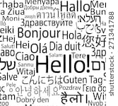
Computing
Computing Continued

Self-Image & Identity / Copyright & Ownership
- Challenge and explain why it is important to reject inappropriate messages about gender online.
- Describe and give examples of issues online that might make others feel sad, worried, anxious
- Describe how I and others can get help and support, both on and offline
- Explain why I should keep asking for help until I get the help I need
- Describe some simple ways that help build a positive online reputation
- I can give examples of content that is permitted to be reused
- I can demonstrate the use of search tool to find and access online content which can be reused by others
- I can demonstrate how to make references to and acknowledge sources I have used from the internet

Networks
- Understand how computers are able to communicate and share information
- Use the internet to share and transfer date to a third party
Using a Computer
- Select, use and combine a variety of software to design and create content for a given audience, including collecting, analysing, evaluating and presenting data and information.
- Design and create a range of programs for a given audience
- Independently use software to help analyse and present data and information.
E-Safety
- Use technology respectfully and responsibly
- Identify a range of ways to report concerns about content and contact in and out of school
- I can describe simple ways to increase privacy on apps and services that provide privacy settings.
- Explain how I am developing an online reputation which will allow other people to form an opinion of me
- I can describe simple ways in which some online content targets people to gain money or information illegally; I can describe strategies to help me identify such content (scams, phishing)
Net Searching
- Recognise trustworthy sources of information on the internet
- Use filters in search engines to find exactly what I am looking for
Coding
- Include use of sequences, selection and repetition with the hardware to explore real world systems
- Solve problems by breaking them down into smaller parts
- Create programs which use variables
- Use loops, sequences, IF statements and variable to alter the way a program runs
- Use logical reasoning to explain how increasingly complex programs work and to detect and correct errors in algorithms and programs efficiently



